RISC AND CISC

RISC (Reduced Instruction Set Architecture)

* RISC is to simplify the hardware by using instruction set consisting of operations like load, store etc. and also consumes less power. In RISC each instruction in a single word.
* RISC Architecture used in mobile phones.

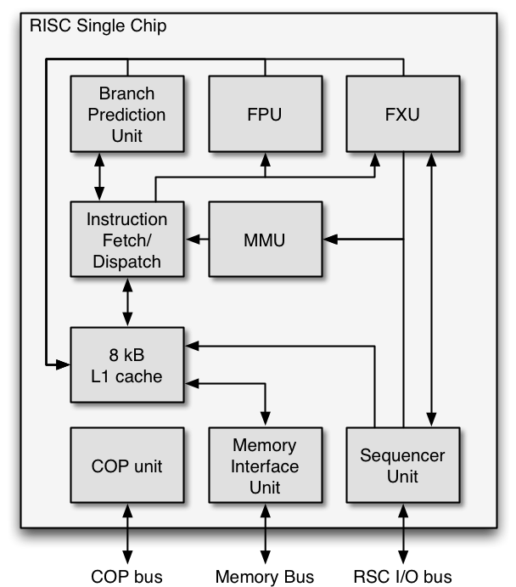

CHARACTERISTICS OF RISC:

* Simple instruction, so simple is the instruction decoding.
* Instruction can fit into single word.
* Instruction gets executed in a single clock cycle.
* Less complex .

ADVANTAGES:

* Faster execution.
* Simpler instruction
* Less power consumption

DISADVANTAGES:

* More number of lines of codes.
* High cost.
* As the number of instructions increases, the memory space required to execute the instruction also increases.

CISC (Complex Instruction Set Architecture)

* CISC consists of small lines of code and each line of code performing multiple tasks.
* CISC Architecture is used computer, IOT devices.
* CISC-Software- simple, hardware –complex.
* RISC-Software-complex, hardware-simple.

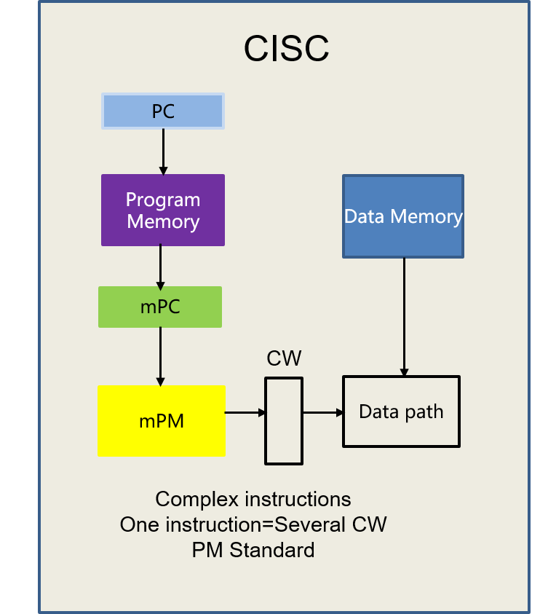

CHARACTERISTICS OF CISC:

* Complex instruction.
* Instruction are larger than word size.
* Instruction is not executed in a single clock cycle.
* Complex instruction set.

ADVANTAGE:

* Reduced code size as multiple instruction are executed at same time .
* As the lines of code , executes multiple instruction it memory space is less.
* Most preffered.

DISADVANTAGE:

* Slower execution.
* More complex design.
* Higher power consumption.

In a survey it is found that , only 20% of instruction is used in Cisc.

|  |  |  |
| --- | --- | --- |
| NO | RISC | CISC |
| 1 | Simpler instruction takes one cycle. | Complex instruction taking multiple cycles |
| 2 | Very few instruction refer memory. | Most of instruction may refer memory. |
| 3 | Few instruction | Many instruction |
| 4 | Highly pipelined | Not pipelined |
| 5 | Multiple register sets | Single register set |
| 6 | Fixed format instructions | Variable format instructions |